CMPE630: Digital Integrated Circuit Design
Laboratory Exercise 04

  - Introduction to Layout and Post-Extraction Simulation

Gloria Mbaka
Performed: 2/7/2025
Submitted: 2/19/2025

Lab Section 01
Instructor: Dr. Zuzak Micheal
TA: Bertola Thomas, and Evans John

By submitting this report, I attest that I neither have given nor have received any unauthorized assistance (including writing, collecting data, plotting figures, tables, or graphs, or using previous student reports as a reference), and I further acknowledge that giving or receiving such assistance will result in a failing grade for this course.
Your Signature: | CGM

Table of Contents
Table of Contents 2
1. Abstract 3
2. Design Methodology 3
2.1 CMOS Inverter Layout 3
3. Results and Analysis 6
3.1 Results of DRC, LVS and Extracted Layout 6
3.2 Simulation Comparisons 10
4. Conclusion 17
5. Questions and Answers 17
What do the extracted resistors and capacitors represent? 17
Draw the equivalent circuit of the extracted view with parasitics. 17
6. Signoff Sheet 19

1. Abstract
This laboratory exercise focused on the design and verification of a CMOS inverter layout using Cadence Virtuoso. The primary objectives were to create the inverter layout, perform a Design Rule Check (DRC) to ensure compliance with fabrication constraints, verify the Layout vs. Schematic (LVS) match, extract parasitic resistances and capacitances (RCX), and conduct post-layout simulations to analyze the impact of parasitic elements. The extracted layout was simulated and compared to the pre-layout simulation results from Lab 2, revealing the effects of parasitic on circuit performance. The post-extraction results indicated a rise time and a fall time that show a degradation compared to pre-layout simulations. The findings demonstrated that parasitic elements contributed to increased propagation delays and reduced maximum operating frequency. This emphasizes the importance of layout optimization in digital integrated circuit design to mitigate parasitic effects and improve overall circuit performance.

2. Design Methodology

2.1 CMOS Inverter Layout

The CMOS inverter layout was designed using Cadence Virtuoso, incorporating fundamental MOSFET design rules. The layout process began with the creation of a schematic diagram (Figure 1), which provided a visual representation of the transistor connections before implementation. The stick diagram ( Figure 2 ) was translated into a physical design using standard layers, including oxide for defining the transistor gate, polysilicon for gate formation and routing, metal1 and metal2 for interconnections, and contacts and vias to establish connections between different layers.

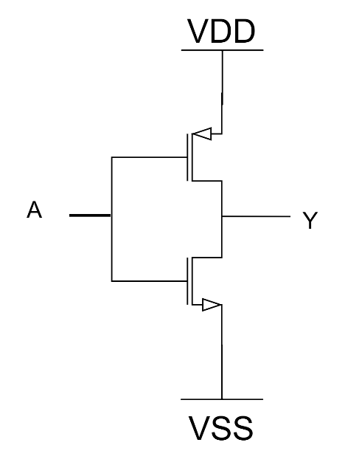
Figure 1: CMOS Inverter Schematics Diagram

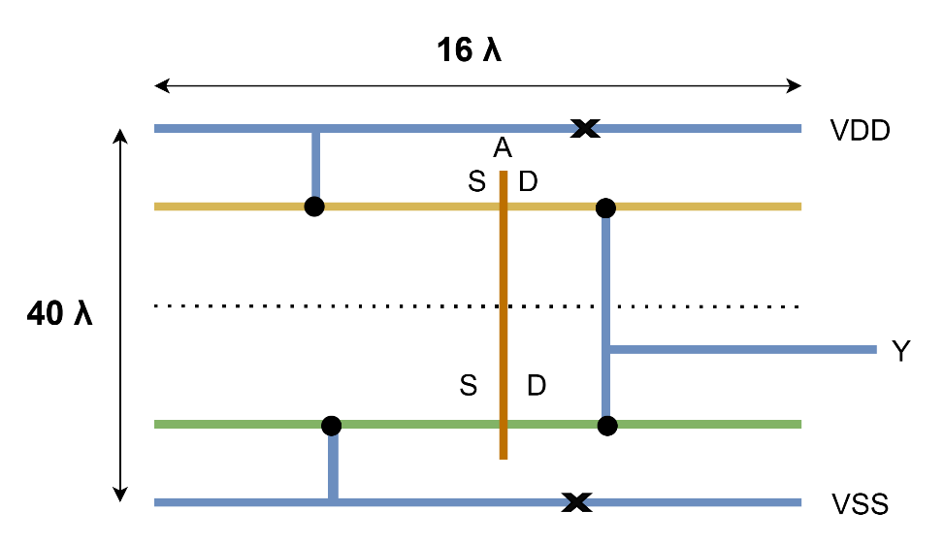
Figure 2: Stick Diagram of CMOS Inverter

The layout consists of multiple layers, each serving a specific function in defining the structure and electrical connectivity of the inverter. The active layer is composed of doped silicon, with n+ diffusion for NMOS and p+ diffusion for PMOS transistors. This layer forms the source and drain regions, enabling charge carrier flow. Above this, the gate oxide layer, made of silicon dioxide (SiO₂), acts as a dielectric insulator between the polysilicon gate and the underlying silicon channel, allowing for proper transistor operation. The polysilicon layer, used for gate formation, is made of doped polysilicon and serves as the control terminal for switching the transistor on and off. To establish electrical continuity between layers, contacts and vias, typically composed of tungsten or titanium, are used to connect diffusion regions, polysilicon, and metal layers.

For signal routing, the metal interconnect layers (Metal1 and Metal2), made of aluminum or copper, are used to connect the input (A), output (Y), and power rails (VDD and VSS). These metal layers provide low-resistance paths for electrical signals, ensuring efficient circuit operation. Finally, a passivation layer, made of silicon nitride or silicon dioxide, is applied to protect the circuit from contamination and environmental damage, enhancing long-term reliability. To optimize performance, area efficiency, and manufacturability, the PMOS transistor width was set to 240 nm, while the NMOS transistor width was 120 nm, ensuring balanced rise and fall times. The gate length was designed at 45 nm, following standard fabrication constraints. The estimated length from the stick diagram width and height from the stick diagram is $16λ and 40λ$ respectively. Thus, the area is estimated to be $64λ^{2}.$ However, overall layout height and width were measured in Cadence Virtuoso to determine the total area occupied by the inverter, ensuring compliance with design rules and integration requirements. The width and height of the layout is 0.72nm and 1.9nm respectively, which gives an area of $1.368 nm^{2}$ . Furthermore, I/O pins for input (A), output (Y), and power rails (VDD, VSS) were placed following industry layout standards. A place-and-route (P&R) boundary was defined for correct integration into automated design workflows. The final layout was carefully inspected to ensure compliance with required design rules before proceeding to verification checks.

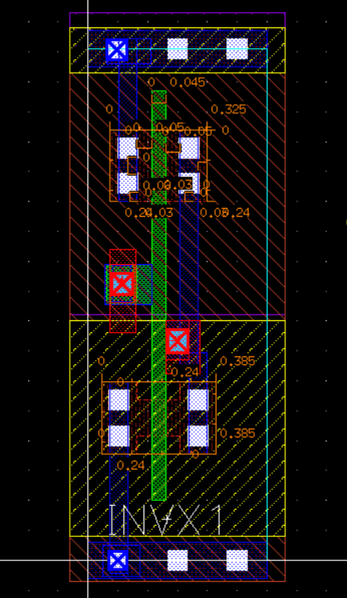

Figure 3: Final Inverter Layout

The Design Rule Check (DRC) was performed using the integrated Physical Verification System (PVS) in Cadence Virtuoso. DRC ensures that the layout conforms to the foundry’s manufacturing constraints, preventing fabrication defects. Errors identified during the initial check included insufficient metal spacing, minimum width violations in polysilicon traces, and improper via placements. These errors were systematically corrected, and after several iterations, a clean DRC check was obtained, confirming compliance with design rules.

LVS was used to verify that the layout matched the original schematic design. This process involved extracting a netlist from the layout and comparing it with the schematic netlist. Discrepancies such as incorrect transistor connections and missing nodes were identified and resolved. A successful LVS check confirmed that the layout and schematic were functionally equivalent, ensuring that no unintended modifications were introduced during the layout design process.

Parasitic resistance and capacitance extraction was conducted using PVS-Quantus QRC. The extracted layout included parasitic resistances from metal interconnects and diffusion regions, as well as parasitic capacitances due to overlapping metal layers and junction effects. These parasitic elements were integrated into the extracted netlist for post-layout simulation to assess their impact on circuit performance.

3. Results and Analysis

3.1 Results of DRC, LVS and Extracted Layout

The results of the DRC verification, LVS and the picture of the extracted layout with parasitic elements is shown below in Figure 4, Figure 5 and Figure 6 respectively.

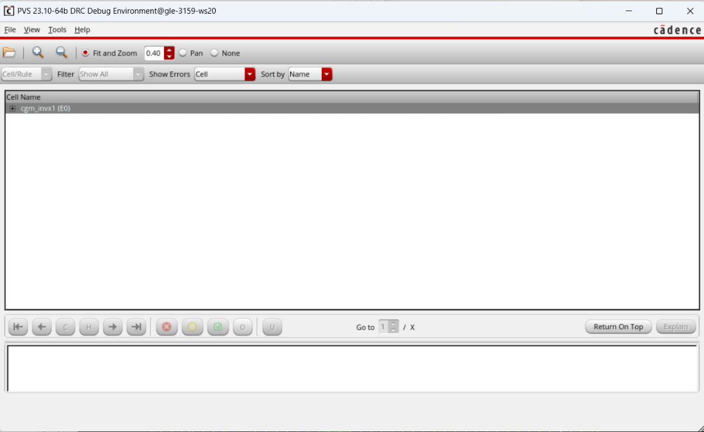
Figure 4: DRC Verification - No Errors Found

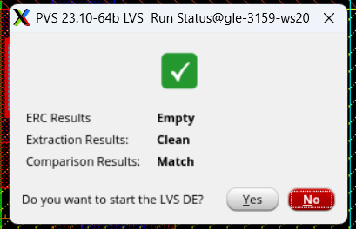

(a)

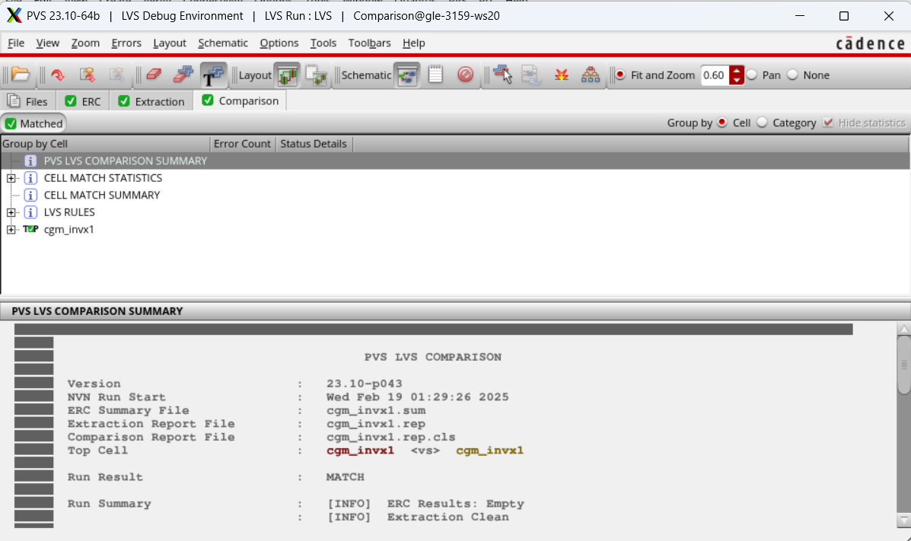

Figure 6: Extracted Layout with Parasitic Elements

The extracted layout of the CMOS inverter contains a total of one NMOS transistor and one PMOS transistor, consistent with the standard CMOS inverter design.

In addition to the transistors, the extracted layout includes parasitic resistors and capacitors that arise from physical fabrication constraints. The layout extraction process revealed the presence of 10 parasitic resistors and 12 parasitic capacitors, which are introduced due to interconnect resistance, diffusion resistance, and overlapping conductive layers. A detailed table listing all the extracted components from the CMOS inverter layout, including transistors, parasitic resistors, and parasitic capacitors, along with their respective values and connections is shown in Table 1(a), 1(b) and 1(c).

Table 1(a) Transistors
Component | Type | Width (W) | Length (L) | Connections
PM0 | PMOS | 240 nm | 45 nm | Drain (Y), Gate (A), Source (VDD)
NM0 | NMOS | 120 nm | 45 nm | Drain (Y), Gate (A), Source (VSS)

Table 1 (b) Parasitic Resistors
Component | Resistance (Ω) | Connections (Between Nodes)
Rj1 | 0.5023 | A → \6:A
Rj2 | 0.5 | Y → \2:Y
Rk1 | 45 | \3:A → \6:A
Rk5 | 31.2754 | VDD → \2:VDD
Rk7 | 37.8171 | VSS → \2:VSS
Rk2 | 31.4078 | \1:Y → \2:Y
Rk3 | 37.6581 | \2:Y → \3:Y
Rl1 | 101.157 | \1:A → \2:A
Rl2 | 8.2281 | \2:A → \3:A
Rl3 | 143.464 | \2:A → \4:A

Table 1 © Parasitic Capacitors
Component | Capacitance (F) | Connections (Between Nodes)
C1 | 3.08221e-17 | A → VSS
C2 | 8.66317e-17 | VDD → VSS
C3 | 2.32118e-17 | Y → VSS
C4 | 3.64039e-17 | \1:A → VSS
C5 | 3.89858e-17 | \4:A → VSS
C6 | 1.07027e-17 | \3:A → VSS
C7 | 6.14295e-17 | \2:Y → VSS
C8 | 4.13967e-17 | \6:A → VSS
C9 | 4.9106e-17 | \1:Y → VSS
C10 | 3.23836e-17 | \2:VDD → VSS
C11 | 3.40284e-17 | \3:Y → VSS
C12 | 2.65702e-17 | \2:A → VSS

The presence of 10 parasitic resistors and 12 parasitic capacitors in the extracted layout indicates interconnect resistance, junction capacitances, and gate overlap capacitances, which contribute to increased propagation delay. These parasitics must be considered in post-layout simulations to ensure the inverter meets timing constraints.

3.2 Simulation Comparisons

The inverter was tested under the same conditions as in Lab 2, with nominal conditions at VDD = 1.1V and Temp = 25°C, worst-case conditions at VDD = 1.0V and Temp = 125°C, and load capacities of 0 fF (unloaded) and 120 fF (loaded). The extracted parasitics impacted inverter performance, increasing rise time, fall time, and propagation delays. The transient simulation waveform from Lab2 is shown below in Figure 7.

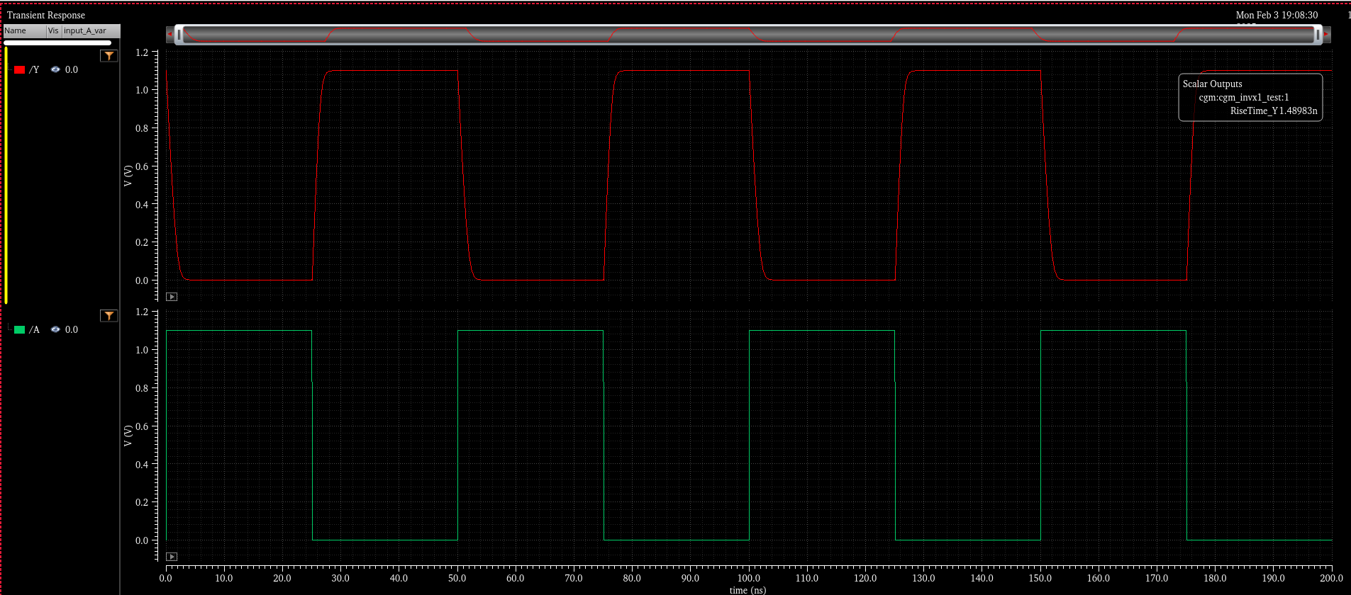

Figure 7: CMOS Inverter Transient Simulation Waveform

The Pre-extraction test results (same as Lab 2) in the ADE XL editor is shown below in figure

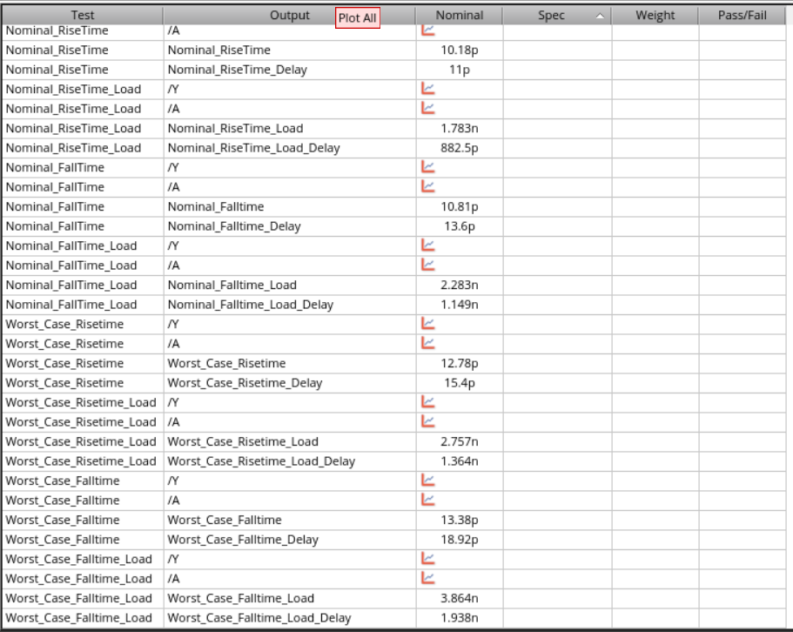

Figure 8: Pre-extraction test results

The post extraction test result is shown below in Figure 9.

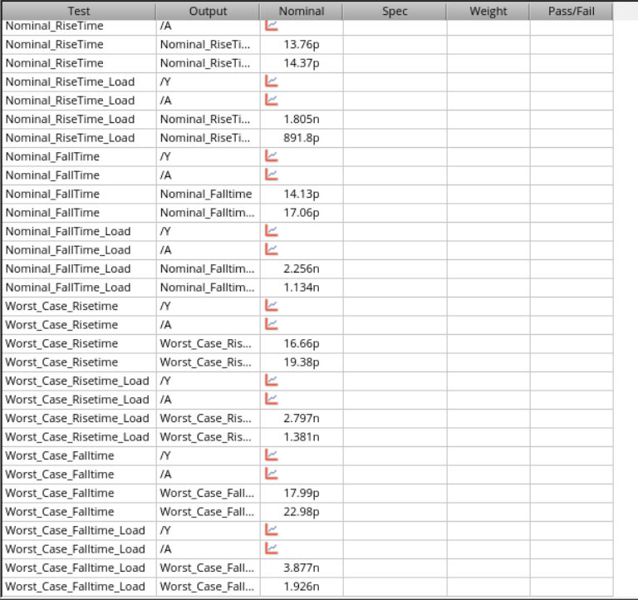

Figure 9: Post extraction results

The post extraction data is summarized below in Table 2.

Table 2: Inverter Results
 | Vdd (V) | Temp (C) | Load (fF) | RiseTime (s) | FallTime (s) | T_{P,HL} (s) | T_{P,LH} (s)
Nominal | 1.1 | 25 | 0 | 13.76p | 14.13p | 17.06p | 14.37p
 | 1.1 | 25 | 120 | 1.805 n | 2.256n | 1.134n | 891.8p
Worst Case | 1 | 125 | 0 | 16.66p | 17.99p | 22.98p | 19.38p
 | 1 | 125 | 120 | 2.797n | 3.877n | 1.926n | 1.381n

The timing simulations of the extracted netlist show that the post-extraction simulation is slower compared to the results from Lab 2 (pre-extraction). This is evident from the increase in rise time, fall time, and propagation delays (T_PHL and T_PLH) across all test conditions. The slower timing in the post-extraction simulation is due to the introduction of parasitic resistances and capacitances that were not present in the pre-extraction results. These parasitics originate from interconnect resistance, diffusion resistance, and unwanted capacitances between metal layers and transistor terminals. The presence of these additional elements increases the RC delay, requiring more time for signals to transition between logic states. Additionally, higher temperatures (125°C) further contribute to increased delay by reducing carrier mobility, which increases resistance and slows switching speed.

The maximum input frequency, $F_{input, max}$represents the highest frequency at which the inverter can reliably process input transitions. It is given by the equation:

$$F_{input, max}=1/\left(t_{rise}+t_{fall}\right)$$

Similarly, the maximum throughput frequency, $F_{throughput, max }$ is determined by the total propagation delay and is given by:

$$F_{throughput, max }=1/\left(T_{P,HL}+T_{P,LH}\right)$$

Using the extracted timing values from both nominal and worst-case conditions, the maximum operating frequencies were computed. The results are summarized in the Table 2 below.

Table 3: Maximum Operating Frequency Calculations
 | VDD (V) | Temp (C) | Load (fF) | $F_{input, max}$ (Hz) | $F_{throughput, max }$ (Hz)
Inverter | 1 | 125 | 0 | $$2.87×{10}^{10}$$ | $$2.36×{10}^{10}$$
 | 1 | 125 | 120 | $$1.51×{10}^{8}$$ | $$3.02×{10}^{8}$$

The calculations for the percentage decrease in maximum operating frequency and throughput are as follows:

$Percentage decrease=\left(\left(F_{unloaded}-F_{loaded}\right)/F_{unloaded}\right)×100$

1. Maximum Input Frequency (F_input,max)
Unloaded: 2.87 × 10¹⁰ Hz
Loaded (120 fF): 1.51 × 10⁸ Hz

$$Percentage Decrease= \left(\frac{\left(2.87 × {10}^{10}- 1.51 × {10}^{8}\right)}{2.87 × {10}^{10}}\right)× 100$$

$$=\frac{\left(2.87 × {10}^{10}- 0.151 × {10}^{10}\right)}{2.87 × {10}^{10}}× 100$$

$$= 99.47\%$$

2. Maximum Throughput Frequency (F_throughput,max)
Unloaded: 2.36 × 10¹⁰ Hz
Loaded (120 fF): 3.02 × 10⁸ Hz

$$Percentage Decrease = \left(\frac{\left(2.36 × {10}^{10}- 3.02 × {10}^{8}\right)}{2.36 × {10}^{10}}\right)× 100$$

$$=\frac{\left(2.36 × {10}^{10}- 0.302 × {10}^{10}\right)}{2.36 × {10}^{10}}× 100$$

$$= 98.72\%$$

These results highlight the significant impact of capacitive loading and worst-case conditions on inverter performance, emphasizing the importance of minimizing parasitic capacitances in high-speed circuit design.

The calculation of the percentage speed change (post-extraction vs. pre-extraction) is shown below:

Using the Formula:
Percentage Change = ((Pre-extraction - Post-extraction) / Pre-extraction) × 100

1. Rise Time
- $Nominal (0 fF load) = ((10.08p - 13.76p) / 10.08p) × 100$
$$= (-3.68p / 10.08p) × 100$$
$$= -36.5\% (slower)$$

- $Nominal (120 fF load) = ((1.783n - 1.805n) / 1.783n) × 100$
$$= (-0.022n / 1.783n) × 100$$
$$= -1.23\% (slower)$$

- $Worst Case (0 fF load) = ((12.78p - 16.66p) / 12.78p) × 100$
$$= (-3.88p / 12.78p) × 100$$
$$= -30.4\% (slower)$$

- $Worst Case (120 fF load) = ((2.757n - 2.797n) / 2.757n) × 100$
$$= (-0.04n / 2.757n) × 100$$
$$= -1.45\% (slower)$$

2. Fall Time
- $Nominal (0 fF load) = ((10.81p - 14.13p) / 10.81p) × 100$
$$= (-3.32p / 10.81p) × 100$$
$$= -30.7\% (slower)$$

- $Nominal (120 fF load) = ((2.283n - 2.256n) / 2.283n) × 100$
$$= (0.027n / 2.283n) × 100$$
$$= +1.18\% (faster)$$

- $Worst Case (0 fF load) = ((13.38p - 17.99p) / 13.38p) × 100$
$$= (-4.61p / 13.38p) × 100$$
$$= -34.5\% (slower)$$

- $Worst Case (120 fF load) = ((3.864n - 3.877n) / 3.864n) × 100$
$$= (-0.013n / 3.864n) × 100$$
$$= -0.34\% (slower)$$

3. Propagation Delay (T_PHL)
- $Nominal (0 fF load) = ((13.6p - 17.06p) / 13.6p) × 100$
$$= (-3.46p / 13.6p) × 100$$
$$= -25.4\% (slower)$$

- $Nominal (120 fF load) = ((1.149n - 1.134n) / 1.149n) × 100$
$$= (0.015n / 1.149n) × 100$$
$$= +1.3\% (faster)$$

- $Worst Case (0 fF load) = ((18.92p - 22.98p) / 18.92p) × 100$
$$= (-4.06p / 18.92p) × 100$$
$$= -21.4\% (slower)$$

- $Worst Case (120 fF load):$
$$((1.938n - 1.926n) / 1.938n) × 100$$
$$= (0.012n / 1.938n) × 100$$
$$= +0.62\% (faster)$$

4. Propagation Delay (T_PLH)
- $Nominal (0 fF load):$
$$= ((11p - 14.37p) / 11p) × 100$$
$$= (-3.37p / 11p) × 100$$
$$= -30.6\% (slower)$$

- $Nominal (120 fF load) = ((882.5p - 891.8p) / 882.5p) × 100$
$$= (-9.3p / 882.5p) × 100$$
$$= -1.06\% (slower)$$

- $Worst Case (0 fF load) = ((15.4p - 19.38p) / 15.4p) × 100$
$$= (-3.98p / 15.4p) × 100$$
$$= -25.9\% (slower)$$

- $Worst Case (120 fF load) = ((1.364n - 1.381n) / 1.364n) × 100$
$$= (-0.017n / 1.364n) × 100$$
$$= -1.25\% (slower)$$

The calculation of speedup/slowdown calculation (post-extraction vs. pre-extraction) is as follows:

Using the formula:

Speed Change (%) = ((Post-extraction - Pre-extraction) / Pre-extraction) × 100

1. Maximum Input Frequency (F_input,max)
- Pre-Extraction: 1.50 × 10⁸ Hz
- Post-Extraction: 1.51 × 10⁸ Hz

- $Speed Change = ((1.51 × 10⁸ - 1.50 × 10⁸) / 1.50 × 10⁸) × 100$
$$= (0.01 × 10⁸ / 1.50 × 10⁸) × 100$$
$$= +0.67\% (slight speedup)$$

2. Maximum Throughput Frequency (F_throughput,max)
- Pre-Extraction: 3.03 × 10⁸ Hz
- Post-Extraction: 3.02 × 10⁸ Hz
- $Speed Change: ((3.02 × 10⁸ - 3.03 × 10⁸) / 3.03 × 10⁸) × 100$
$$= (-0.01 × 10⁸ / 3.03 × 10⁸) × 100$$
$$= -0.33\% (slight slowdown)$$

4. Conclusion
The post-layout simulation results demonstrated the impact of parasitic elements on inverter performance. The extracted inverter exhibited increased propagation delay, reduced maximum operating frequency, and degraded switching characteristics compared to pre-layout simulations. These findings highlight the importance of layout optimization in mitigating parasitic effects and ensuring robust digital circuit performance. Future improvements could include reducing parasitic capacitances by optimizing metal routing and minimizing diffusion areas.

5. Questions and Answers

What do the extracted resistors and capacitors represent?
The extracted resistances correspond to poly, metal, and diffusion regions, while capacitances arise from inter-layer and junction parasitics.
Draw the equivalent circuit of the extracted view with parasitics.

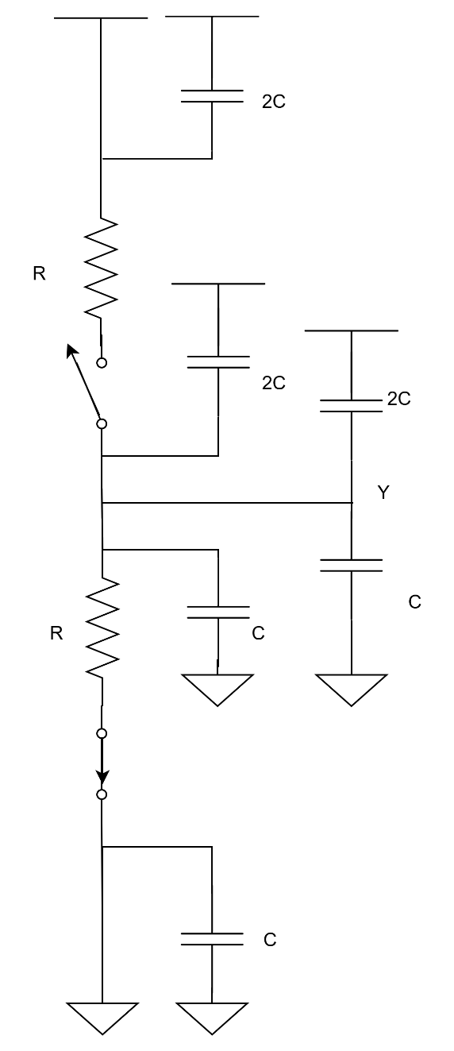

Figure 6: Equivalent Circuit with Extracted Parasitics

6. Signoff Sheet

